Data Generation & Clustering

**Imports**

import matplotlib.pyplot as plt

import numpy as np

import random as r

import math as m

**Data Generation**

**Deterministic Data Generation**

def determDataGen(numClusters, centX, centY, clustSize, clustRad):

    # cluster x and y coordinates

    px = []

    py = []

    for j in range(numClusters):

        # cluster centers

        cx = centX[j]

        cy = centY[j]

        ang = 0

        radInc = clustRad / 5

        pointsPerRad = 4

        angInc = 360 / pointsPerRad

        for k in range(clustSize):

            myX = cx + clustRad * np.cos(np.deg2rad(ang))

            myY = cy + clustRad * np.sin(np.deg2rad(ang))

            # append new cluster point

            px.append(myX)

            py.append(myY)

            ang = ang + angInc

            if(ang > 360):

                ang = 0

                clustRad += radInc

                pointsPerRad *= 2

                angInc = 360 / pointsPerRad

            #

        #

    #

    return px, py

# determDataGen

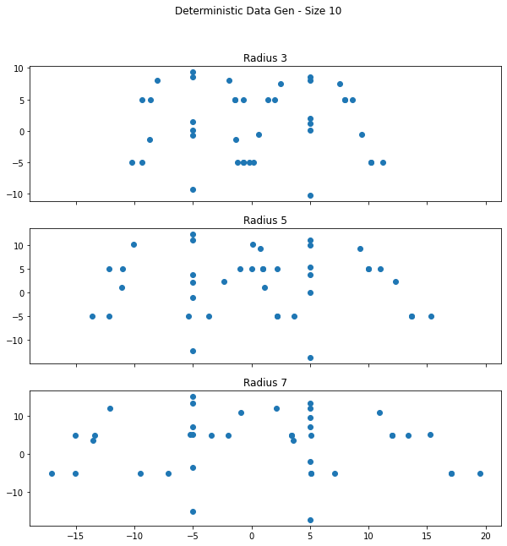

***Non-Deterministic Data Generation***

def nonDetermDataGen(numClusters, centX, centY, clustSize, clustRad):

    # cluster x and y coordinates

    px = []

    py = []

    for clust in range(numClusters):

        # cluster centers

        cx = centX[clust]

        cy = centY[clust]

        for clust_pnt in range(clustSize):

            angD = r.randint(0,359)

            magnitude = r.random() * clustRad

            myX = cx + magnitude * np.cos(np.deg2rad(angD))

            myY = cy + magnitude * np.sin(np.deg2rad(angD))

            # append new cluster point

            px.append(myX)

            py.append(myY)

        #

    #

    return px, py

# nonDetermDataGenA picture containing text, light, different, wire

Description automatically generatedCalendar

Description automatically generated

***Function Calls to Generate Plots:***

pop_size = [10, 30, 100]

rad_size = [3, 5, 7]

determData = {}

nonDetermData = {}

for ind_pop, pop in enumerate(pop_size):

    det_fig, det_axs = plt.subplots(len(pop_size), sharex = True, figsize = (10, 10))

    det_fig.suptitle(f'Deterministic Data Gen - Size {pop}')

    nonDet_fig, nonDet_axs = plt.subplots(len(pop_size), sharex = True, figsize = (10, 10))

    nonDet_fig.suptitle(f'Non Deterministic Data Gen - Size {pop}')

    for ind_rad, rad in enumerate(rad_size):

        key = f's{pop}_r{rad}'

        det_data_gen = determDataGen(4, [5, -5, -5, 5], [5, 5, -5, -5], pop, rad)

        det_axs[ind_rad].scatter(det_data_gen[0], det_data_gen[1])

        det_axs[ind_rad].set_title(f'Radius {rad}')

        determData[key] = det_data_gen

        nonDet_data_gen = nonDetermDataGen(4, [5, -5, -5, 5], [5, 5, -5, -5], pop, rad)

        nonDet_axs[ind_rad].scatter(nonDet_data_gen[0], nonDet_data_gen[1])

        nonDet_axs[ind_rad].set_title(f'Radius {rad}')

        nonDetermData[key] = nonDet_data_gen

    #

#

**Clustering**

***Ad Hoc Clustering***

def adHocClustering(x, y, maxDist):

    nClusts = 0 # number of clusters

    clusters = [] # the clusters

    pntsPerCluster = [] # number of pnts per cluster

    for j in range(len(x)): # loop through each data pnt

        pnt = [x[j], y[j]] # for convenience

        if(nClusts == 0): # no clusters?

            clusters.append(pnt) # this is the first pnt of the first cluster

            nClusts = nClusts + 1 # increment clusters count and...

            pntsPerCluster.append(1) # create item to increment pnts for that cluster

        else: # find closest cluster

            dists = [m.dist(pnt, cluster) for cluster in clusters]

            closeDists = min(dists) # closest cluster

            closeIndex = dists.index(min(dists)) # index of the closest cluster

            if(closeDists < maxDist): # close enough

                # most and rest counts for merging

                most = pntsPerCluster[closeIndex] / (pntsPerCluster[closeIndex] + 1)

                rest = 1 / (pntsPerCluster[closeIndex] + 1)

                # merge centroid

                clusters[closeIndex] = [((clusters[closeIndex][0] * most) + (pnt[0] * rest)), ((clusters[closeIndex][1] * most) + (pnt[1] * rest))]

                pntsPerCluster[closeIndex] = pntsPerCluster[closeIndex] + 1 # increment pntsPerCluster

            else: # new cluster

                clusters.append(pnt) # first pnt of a new cluster

                nClusts = nClusts + 1 # increment clusters and...

                pntsPerCluster.append(1) # add new item to increment points for that cluster

            #

        #

    #

    return nClusts, clusters, pntsPerCluster

# adHocClustering

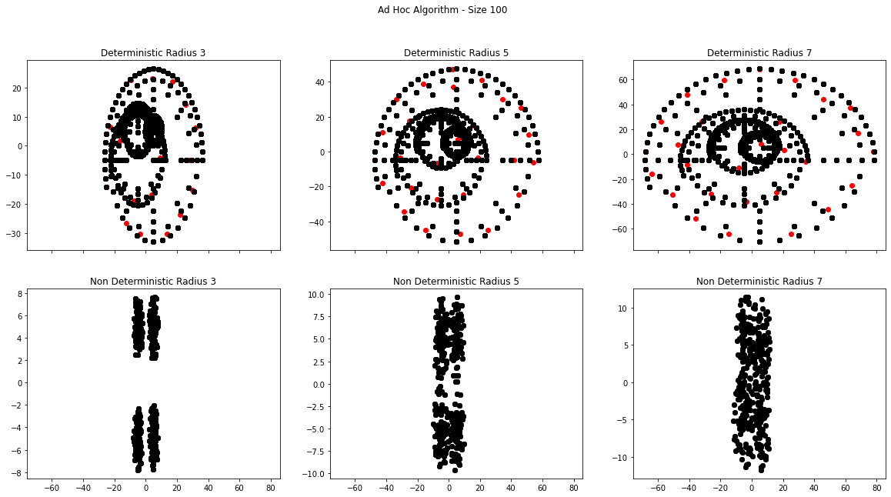

***Function Calls to Generate Plots:***

for ind_pop, pop in enumerate(pop_size):

    fig_10, axs_10 = plt.subplots(2, 3, sharex = True, figsize = (20, 10))

    fig_10.suptitle(f'Ad Hoc Algorithm - Size {pop}')

    max_dist = 8

    for ind_rad, rad in enumerate(rad_size):

        nClusts_determ, clusters_determ, pntsPerCluster_determ = adHocClustering(determData[f's{pop}_r{rad}'][0], determData[f's{pop}_r{rad}'][1], max_dist)

        for j in range(nClusts_determ):

            axs_10[0][ind_rad].scatter(clusters_determ[j][0], clusters_determ[j][1], color = 'r')

            axs_10[0][ind_rad].scatter(determData[f's{pop}_r{rad}'][0], determData[f's{pop}_r{rad}'][1], color = 'k')

        #

        axs_10[0][ind_rad].set_title(f'Deterministic Radius {rad}')

        nClusts_nonDeterm, clusters_nonDeterm, pntsPerCluster_nonDeterm = adHocClustering(nonDetermData[f's{pop}_r{rad}'][0], nonDetermData[f's{pop}_r{rad}'][1], max_dist)

        for j in range(nClusts_nonDeterm):

            axs_10[1][ind_rad].scatter(clusters_nonDeterm[j][0], clusters_nonDeterm[j][1], color = 'r')

            axs_10[1][ind_rad].scatter(nonDetermData[f's{pop}_r{rad}'][0], nonDetermData[f's{pop}_r{rad}'][1], color = 'k')

        #

        axs_10[1][ind_rad].set_title(f'Non Deterministic Radius {rad}')

        max_dist += 4

    #

#

***K Means Clustering***

def kMeans(x, y, k):

    centroids_x = []

    centroids_y = []

    # choose k random points >> new centers

    for i in range(k):

        rndm_indx = r.randint(0, len(x)-1)

        centroids_x.append(x[rndm_indx])

        centroids_y.append(y[rndm_indx])

    #

    clusters_x = {}

    clusters_y = {}

    for i in range(100):

        clusters_x = {}

        clusters_y = {}

        # assign data to clusters

        for centroid_indx in range(len(centroids_x)):

            pnts_x = [] # holds the list of points that match the current cluster

            pnts_y = []

            # loop through the points

            for pnt_indx in range(len(x)):

                # find dist from centers

                dist = [m.dist([centroids_x[j], centroids_y[j]], [x[pnt_indx], y[pnt_indx]]) for j in range(len(centroids_x))]

                # if the min(dist) is this centroid assign it to that cluster

                if centroid_indx == dist.index(min(dist)):

                    pnts_x.append(x[pnt_indx])

                    pnts_y.append(y[pnt_indx])

                #

                # add list of cluster pnts to the clusters dict

                clusters_x[centroid_indx] = pnts_x

                clusters_y[centroid_indx] = pnts_y

            #

        #

        for key in clusters_x:

            avg_x = np.mean(clusters_x[key])

            avg_y = np.mean(clusters_y[key])

            centroids_x[key] = avg_x

            centroids_y[key] = avg_y

        #

    #

    return centroids_x, centroids_y, clusters_x, clusters_y

#

***Function Calls to Generate Plots:***

for ind_pop, pop in enumerate(pop_size):

    fig, axs = plt.subplots(2, 3, sharex = True, figsize = (20, 10))

    fig.suptitle(f'K Means Clustering - Size {pop}')

    for ind_rad, rad in enumerate(rad_size):

        centersX_determ, centersY_determ, clustX_determ, clustY_determ = kMeans(determData[f's{pop}_r{rad}'][0], determData[f's{pop}_r{rad}'][1], 4)

        axs[0][ind_rad].scatter(centersX_determ, centersY_determ, color = 'k')

        for j in range(len(clustX_determ)):

            axs[0][ind_rad].scatter(clustX_determ[j], clustY_determ[j])

        axs[0][ind_rad].set_title(f'Deterministic Radius {rad}')

        centersX_nonDeterm, centersY_nonDeterm, clustX_nonDeterm, clustY_nonDeterm = kMeans(nonDetermData[f's{pop}_r{rad}'][0], nonDetermData[f's{pop}_r{rad}'][1], 4)

        axs[1][ind_rad].scatter(centersX_nonDeterm, centersY_nonDeterm, color = 'k')

        for j in range(len(clustX_nonDeterm)):

            axs[1][ind_rad].scatter(clustX_nonDeterm[j], clustY_nonDeterm[j])

        axs[1][ind_rad].set_title(f'Deterministic Radius {rad}')

    #

#